Programming Paradigms
Programming paradigms are fundamental styles or approaches to writing software codes.

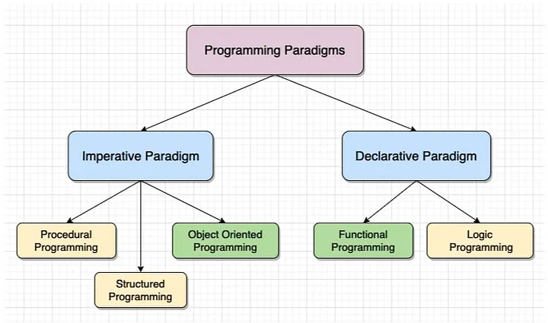

1- Imperative Programming
Definition: focuses on how to perform tasks using statements that change a program state
a) Procedural Programming
-organizes code into procedures/ functions
- top down
b) Object-Oriented Programming (OOP)
-Organizes code into object using data or methods
-Key principles: Encapsulation, Inheritance, Polymorphism, Abstraction.
C) Parallel processing
parallel processing is where multiple tasks, solving problems sequentially one step at a time. parallel processing break problems into smaller tasks.

2- Declarative programming
Definition: focuses on what the program should accomplish without specifying control flow. Declarative logic rather than steps.
a) functional programming
- functional programming control flow is expressed by combining function call rather than by assigning values to variables.
b) logic programming
-logic programming is uses a set of rules and facts to describe constraints and relationships within problem domain.
c) database SQL
database is the flow and behavior of a program are determined by data instead of hard coded instructions.

